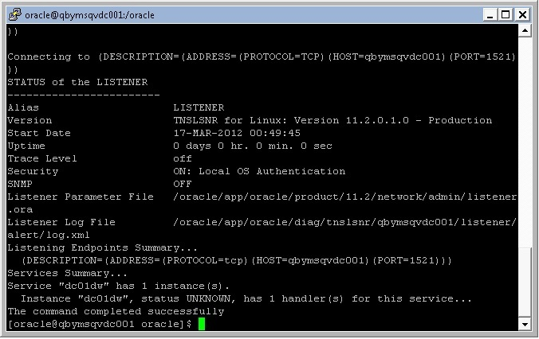

Listener started

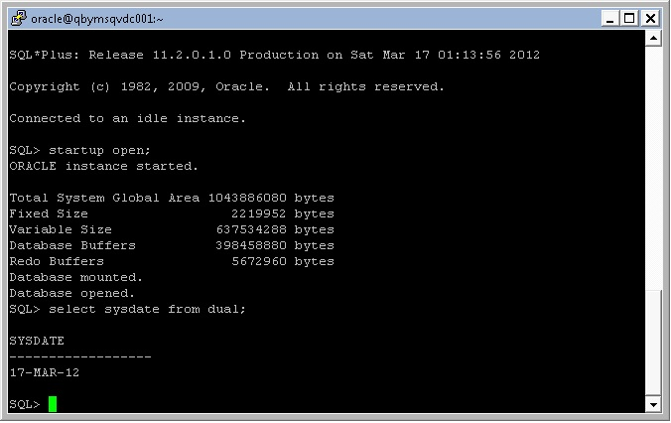

Instance started; db mounted; db opened.

Select sysdate from dual.